Lesson 19: Translating Graphs of Functions

Classwork

Opening Exercise

Graph each set of three functions in the same coordinate plane (on your graphing calculator or a piece of graph paper). Then, explain what similarities and differences you see among the graphs.

|  |  |  |
| --- | --- | --- |
|  |  |  |

**Example**

For each graph, answer the following:

* What is the parent function?
* How does the translated graph relate to the graph of the parent function?
* Write the formula for the function depicted by the translated graph.
  1. 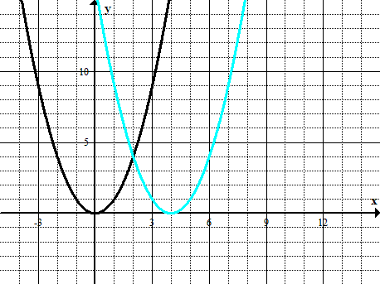
  2. 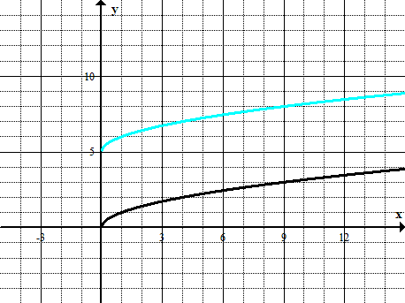
  3. 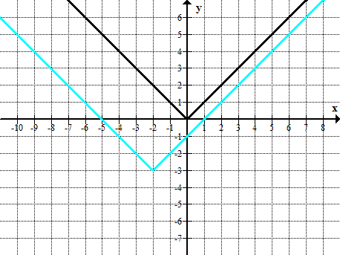

Exercises

1. For each of the following graphs, use the formula for the parent function $f$ to write the formula of the translated function.

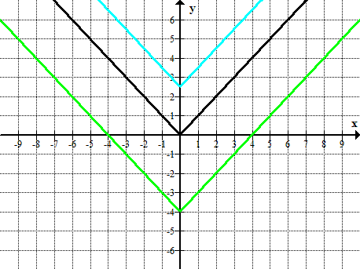

* 1. 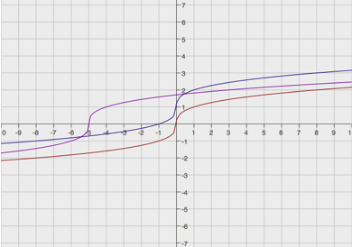

1. Below is a graph of a piecewise function $f$ whose domain is $-5≤x≤3$. Sketch the graphs of the given functions on the same coordinate plane. Label your graphs correctly.

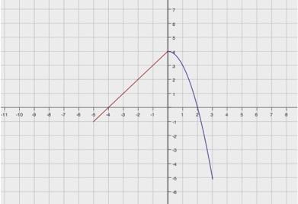

1. Match the correct equation and description of the function with the given graphs.

|  |  |  |
| --- | --- | --- |
| **Graphs** | **Equation** | **Description** |
| $$y=f(x)$$ Equation _________ Description ___________ | E1. $y={(x-3)}^{2}$ E2. $y={(x+2)}^{2}-3$ E3. $y={-(x-3)}^{2}-2$ E4. $y={(x-2)}^{2}-3$ | D1. The graph of the parent function is translated down $3$ units and left $2$ units.  D2. The graph of the function does not have an $x$-intercept.  D3. The coordinate of the $y$-intercept is $(0, 1)$, and both $x$-intercepts are positive.  D4. The graph of the function has only one $x$-intercept. |
| $$y=g\left(x\right)$$ Equation _________ Description ___________ |
| $$y=h(x)$$ Equation _________ Description ___________ |
| $$y=p(x)$$ Equation _________ Description ___________ |

Problem Set

1. 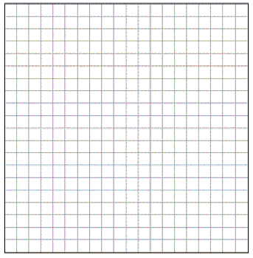Graph the functions in the same coordinate plane. Do not use a graphing calculator.
$$f\left(x\right)=\sqrt{x}$$

$$p(x)=10+\sqrt{x}$$

$$q\left(x\right)=\sqrt{x+8}$$

2. Write a function that translates the graph of the parent function $f\left(x\right)=x^{2}$ down $7.5$ units and right $2.5$ units.
3. How would the graph of $f(x)=|x|$ be affected if the function were transformed to $f(x)=|x+6|+10$?
4. Below is a graph of a piecewise function $f$ whose domain is the interval $-4≤x≤2$. Sketch the graph of the given functions below. Label your graphs correctly.

$g\left(x\right)=f\left(x\right)-1$ $h(x)=g(x-2)$ [Be careful; this one might be a challenge.]

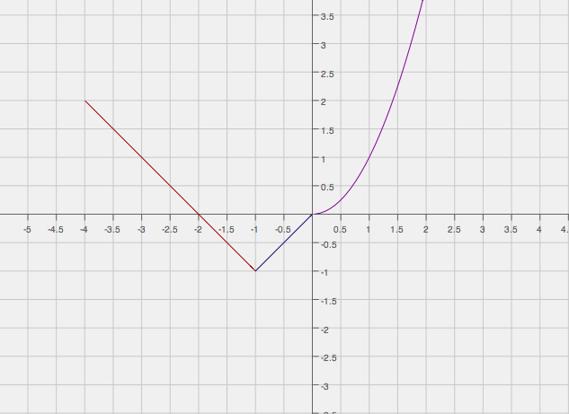

1. Study the graphs below. Identify the parent function and the transformations of that function depicted by the second graph. Then, write the formula for the transformed function.

